Dear Parents and Guardians:
PowerSchool has introduced a new feature called Single Sign-On. Parents can now use one login to access all of their children’s grades and attendance. Ness City Schools will activate this feature on August 2, 2014 at 9:00 a.m. After 9:00 a.m., you will need to create a new parent/guardian username and password to access PowerSchool. Old parent/guardian accounts will no longer work. Your new login will allow you to see all your children in the district.

Go to https://usd303.powerschool.com/public/home.html or click on the PowerSchool link
at the top of the screen at www.nesscityschools.org

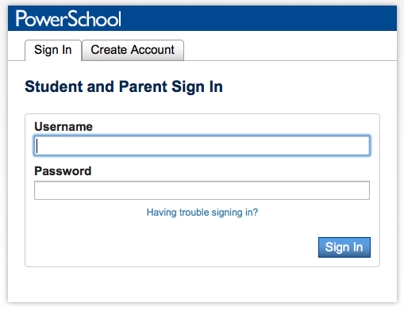
1. Choose Create Account

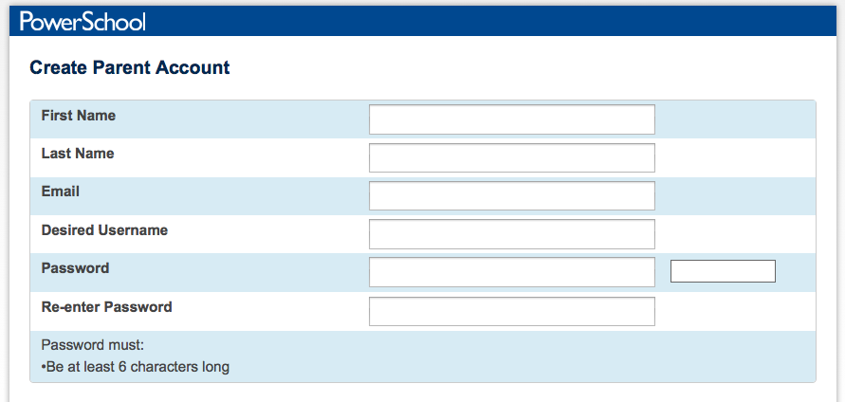
2. Fill in your information including new password, which must be at least 6 characters.

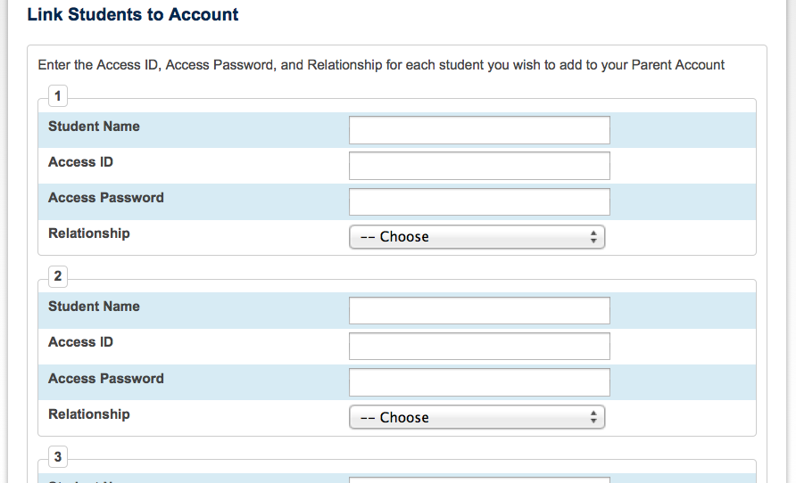
3. Enter the Access ID & Access Password (your old ID and password for your student) to link your student(s) to your new login.

If you have more then one student, you will see tabs to switch between your students’ information.
Notes: The old parent/guardian username and password will not work to log in.
Student username and passwords will not change.

If you lose your PowerSchool Parent Portal username or password, go to the Parent Portal login page and click “Having trouble signing in?” The Recover Account Sign-In Information Page will appear and you will be able to obtain your login information.

Thank you for using PowerSchool!

